**Artificial Intelligence Interview Questions:** [**RnF**](https://www.edureka.co/blog/interview-questions/artificial-intelligence-interview-questions/)

Ever since we realized how Artificial Intelligence is positively impacting the market, nearly every large business is on the lookout for AI professionals to help them make their vision a reality. In this Artificial Intelligence Interview Questions blog, I have collected the most frequently asked questions by interviewers. These questions are collected after consulting with [Artificial Intelligence Certification Training Experts](https://www.edureka.co/masters-program/machine-learning-engineer-training).

In case you have attended any Artificial Intelligence interview in the recent past, do paste those interview questions in the comments section and we’ll answer them at the earliest. You can also comment below if you have any questions in your mind, which you might face in your Artificial Intelligence interview.

In this blog on Artificial Intelligence Interview Questions, I will be discussing the top Artificial Intelligence related questions asked in your interviews. So, for your better understanding I have divided this blog into the following 3 sections:

1. [Artificial Intelligence Basic Level Interview Questions](https://www.edureka.co/blog/interview-questions/artificial-intelligence-interview-questions/#Artificial%20Intelligence%20Basic%20Level%20Interview%20Questions)
2. [Artificial Intelligence Intermediate Level Interview Questions](https://www.edureka.co/blog/interview-questions/artificial-intelligence-interview-questions/#Artificial%20Intelligence%20Intermediate%20Level%20Interview%20Questions)
3. [Artificial Intelligence Scenario Based Interview Question](https://www.edureka.co/blog/interview-questions/artificial-intelligence-interview-questions/#Artificial%20Intelligence%20Scenario%20Based%20Interview%20Question)

**Artificial Intelligence Basic Level Interview Questions**

**Q1. What is the difference between AI, Machine Learning and Deep Learning?**

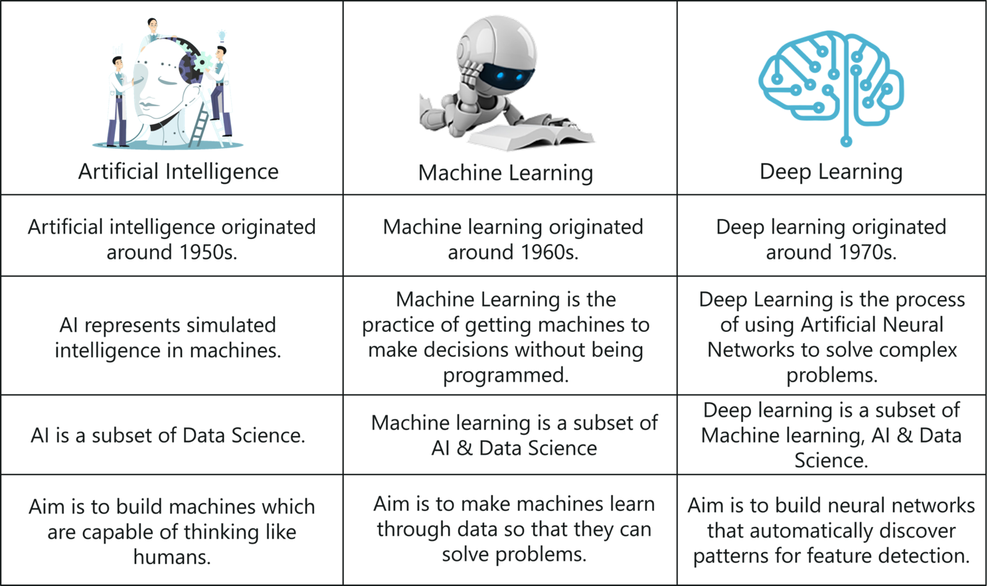

*Artificial Intelligence vs Machine Learning vs Deep Learning – Artificial Intelligence Interview Questions – Edureka*

**Q2. What is Artificial Intelligence? Give an example of where AI is used on a daily basis.**

 “Artificial Intelligence (AI) is an area of computer science that emphasizes the creation of intelligent machines that work and react like humans.” “The capability of a machine to imitate the intelligent human behavior.”

******

*Google’s Search Engine – Artificial Intelligence Interview Questions – Edureka*

***Google’s Search Engine***  
One of the most popular [AI Applications](https://www.edureka.co/blog/artificial-intelligence-applications/) is the google search engine. If you open up your chrome browser and start typing something, Google immediately provides recommendations for you to choose from. The logic behind the search engine is Artificial Intelligence.

AI uses predictive analytics, NLP and [Machine Learning](https://www.edureka.co/blog/what-is-machine-learning/) to recommend relevant searches to you. These recommendations are based on data that Google collects about you, such as your search history, location, age, etc. Thus, Google makes use of AI, to predict what you might be looking for.

**Q3. What are the different types of AI?**

* **Reactive Machines AI:** Based on present actions, it cannot use previous experiences to form current decisions and simultaneously update their memory.  
  Example: Deep Blue
* **Limited Memory AI:** Used in self-driving cars. They detect the movement of vehicles around them constantly and add it to their memory.
* **Theory of Mind AI:** Advanced AI that has the ability to understand emotions, people and other things in the real world.
* **Self Aware AI:** AIs that posses human-like consciousness and reactions. Such machines have the ability to form self-driven actions.
* **Artificial Narrow Intelligence (ANI):** General purpose AI, used in building virtual assistants like Siri.
* **Artificial General Intelligence (AGI):** Also known as strong AI. An example is the Pillo robot that answers questions related to health.
* **Artificial Superhuman Intelligence (ASI):** AI that possesses the ability to do everything that a human can do and more. An example is the Alpha 2 which is the first humanoid ASI robot.

**Q4. Explain the different domains of Artificial Intelligence.**

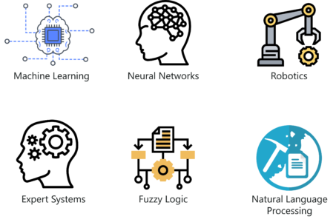

*Domains Of AI – Artificial Intelligence Interview Questions – Edureka*

* **Machine Learning:** It’s the science of getting computers to act by feeding them data so that they can learn a few tricks on their own, without being explicitly programmed to do so.
* **Neural Networks:** They are a set of algorithms and techniques, modeled in accordance with the human brain. [Neural Networks](https://www.edureka.co/blog/neural-network-tutorial/) are designed to solve complex and advanced machine learning problems.
* **Robotics:** Robotics is a subset of AI, which includes different branches and application of robots. These Robots are artificial agents acting in a real-world environment. An AI Robot works by manipulating the objects in it’s surrounding, by perceiving, moving and taking relevant actions.
* **Expert Systems:** An expert system is a computer system that mimics the decision-making ability of a human. It is a computer program that uses artificial intelligence (AI) technologies to simulate the judgment and behavior of a human or an organization that has expert knowledge and experience in a particular field.
* **Fuzzy Logic Systems:** Fuzzy logic is an approach to computing based on “degrees of truth” rather than the usual “true or false” (1 or 0) boolean logic on which the modern computer is based. Fuzzy logic Systems can take imprecise, distorted, noisy input information.
* **Natural Language Processing:** Natural Language Processing (NLP) refers to the Artificial Intelligence method that analyses natural human language to derive useful insights in order to solve problems.

**Q5. How is Machine Learning related to Artificial Intelligence?**

[Artificial Intelligence](https://www.edureka.co/blog/what-is-artificial-intelligence) is a technique that enables machines to mimic human behavior. Whereas, Machine Learning is a subset of Artificial Intelligence. It is the science of getting computers to act by feeding them data and letting them learn a few tricks on their own, without being explicitly programmed to do so.

Therefore Machine Learning is a technique used to implement Artificial Intelligence.

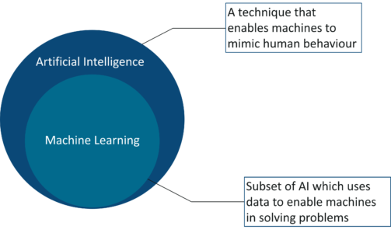

*Artificial Intelligence vs Machine Learning – Artificial Intelligence Interview Questions – Edureka*

**Q6. What are the different types of Machine Learning?**

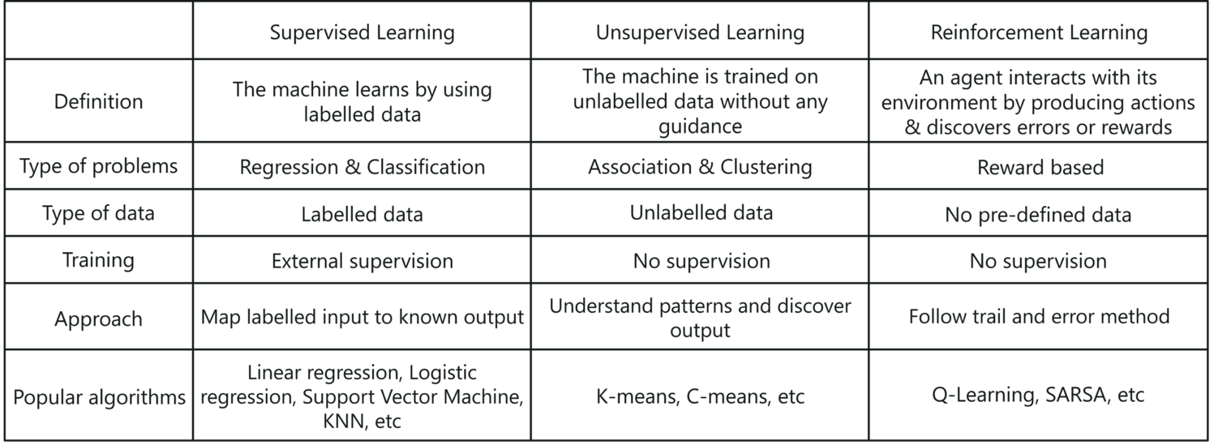

*Types Of Machine Learning – Artificial Intelligence Interview Questions – Edureka*

**Q7. What is Q-Learning?**

*The Q-learning is a Reinforcement Learning algorithm in which an agent tries to learn the optimal policy from its past experiences with the environment. The past experiences of an agent are a sequence of state-action-rewards:*

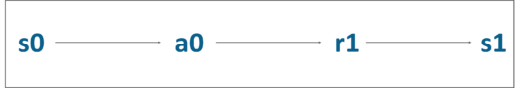

*What Is Q-Learning? – Artificial Intelligence Interview Questions – Edureka*

In the above state diagram, the Agent(a0) was in State (s0) and on performing an Action (a0), which resulted in receiving a Reward (r1) and thus being updated to State (s1).

**Q8. What is Deep Learning?**

[Deep learning](https://www.edureka.co/blog/what-is-deep-learning) imitates the way our brain works i.e. it learns from experiences. It uses the concepts of neural networks to solve complex problems.

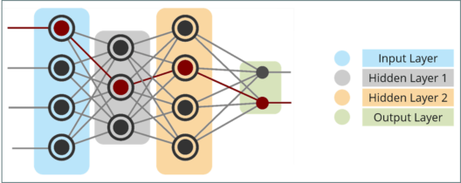

*What Is Deep Learning? – Artificial Intelligence Interview Questions – Edureka*

Any Deep neural network will consist of three types of layers:

* **Input Layer:** This layer receives all the inputs and forwards them to the hidden layer for analysis
* **Hidden Layer:** In this layer, various computations are carried out and the result is transferred to the output layer. There can be n number of hidden layers, depending on the problem you’re trying to solve.
* **Output Layer:** This layer is responsible for transferring information from the neural network to the outside world.

**Q9. Explain how Deep Learning works.**

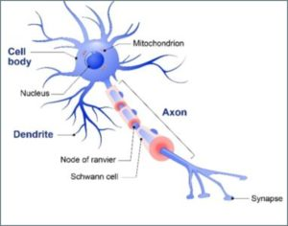

*Biological Neurons – Artificial Intelligence Interview Questions – Edureka*

* Deep Learning is based on the basic unit of a brain called a brain cell or a neuron. Inspired from a neuron, an artificial neuron or a perceptron was developed.
* A biological neuron has dendrites which are used to receive inputs.
* Similarly, a perceptron receives multiple inputs, applies various transformations and functions and provides an output.
* Just like how our brain contains multiple connected neurons called neural network, we can also have a network of artificial neurons called perceptron’s to form a Deep neural network.

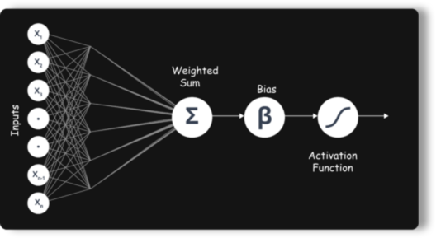

*Deep Neural Network – Artificial Intelligence Interview Questions – Edureka*

* An Artificial Neuron or a Perceptron models a neuron which has a set of inputs, each of which is assigned some specific weight. The neuron then computes some function on these weighted inputs and gives the output.

**Q10. Explain the commonly used Artificial Neural Networks.**

**Feedforward Neural Network**

* The simplest form of ANN, where the data or the input travels in one direction.
* The data passes through the input nodes and exit on the output nodes. This neural network may or may not have the hidden layers.

[**Convolutional Neural Network**](https://www.edureka.co/blog/convolutional-neural-network/)

* Here, input features are taken in batch wise like a filter. This will help the network to remember the images in parts and can compute the operations.
* Mainly used for signal and image processing

[**Recurrent Neural Network(RNN)**](https://www.edureka.co/blog/recurrent-neural-networks/)**– Long Short Term Memory**

* Works on the principle of saving the output of a layer and feeding this back to the input to help in predicting the outcome of the layer.
* Here, you let the neural network to work on the front propagation and remember what information it needs for later use
* This way each neuron will remember some information it had in the previous time-step.

[**Autoencoders**](https://www.edureka.co/blog/autoencoders-tutorial/)

* These are unsupervised learning models with an input layer, an output layer and one or more hidden layers connecting them.
* The output layer has the same number of units as the input layer. Its purpose is to reconstruct its own inputs.
* Typically for the purpose of dimensionality reduction and for learning generative models of data.

**Q11. What are Bayesian Networks?**

 A Bayesian network is a statistical model that represents a set of variables and their conditional dependencies in the form of a directed acyclic graph.

On the occurrence of an event, Bayesian Networks can be used to predict the likelihood that any one of several possible known causes was the contributing factor.

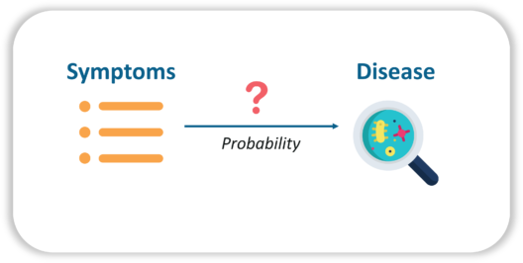

*Bayesian Network – Artificial Intelligence Interview Questions – Edureka*

For example, a Bayesian network could be used to study the relationship between diseases and symptoms. Given various symptoms, the Bayesian network is ideal for computing the probabilities of the presence of various diseases.

**Q12. Explain the assessment that is used to test the intelligence of a machine.**

*In artificial intelligence (AI), a Turing Test is a method of inquiry for determining whether or not a computer is capable of thinking like a human**being.*

**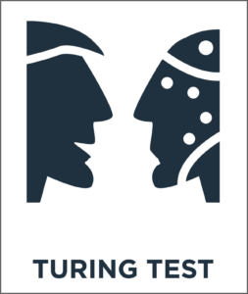**

*AI Turing Test – Artificial Intelligence Interview Questions – Edureka*

**Artificial Intelligence Intermediate Level Interview Questions**

**Q1. How does Reinforcement Learning work? Explain with an example.**

Generally, a Reinforcement Learning (RL) system is comprised of two main components:

1. An agent
2. An environment

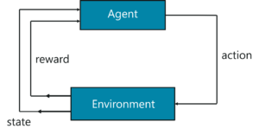

*Reinforcement Learning – Artificial Intelligence Interview Questions – Edureka*

* The environment is the setting that the agent is acting on and the agent represents the RL algorithm.
* The RL process starts when the environment sends a state to the agent, which then based on its observations, takes an action in response to that state.
* In turn, the environment sends the next state and the respective reward back to the agent. The agent will update its knowledge with the reward returned by the environment to evaluate its last action.
* The loop continues until the environment sends a terminal state, which means the agent has accomplished all his tasks.

To understand this better, let’s suppose that our agent is learning to play counterstrike. The RL process can be broken down into the below steps:



*Counter-Strike Example – Artificial Intelligence Interview Questions – Edureka*

1. The RL Agent (Player1) collects state S⁰ from the environment (Counterstrike game)
2. Based on the state S⁰, the RL agent takes an action A⁰, (Action can be anything that causes a result i.e. if the agent moves left or right in the game). Initially, the action is random
3. The environment is now in a new state S¹ (new stage in the game)
4. The RL agent now gets a reward R¹ from the environment. This reward can be additional points or coins
5. This RL loop goes on until the RL agent is dead or reaches the destination, and it continuously outputs a sequence of state, action, and reward.

To learn more about Reinforcement Learning you can go through this video recorded by our Machine Learning experts.

**Reinforcement Learning Tutorial | Reinforcement Learning Example Using Python | Edureka**

*In this Edureka video on “Reinforcement Learning Tutorial” you will get an in-depth understanding of how reinforcement learning is used in the real world.*

**Q2. Explain Markov’s decision process with an example.**

 The mathematical approach for mapping a solution in Reinforcement Learning is called Markov’s  Decision Process (MDP).

The following parameters are used to attain a solution using MDP:

* Set of actions, A
* Set of states, S
* Reward, R
* Policy, π
* Value, V

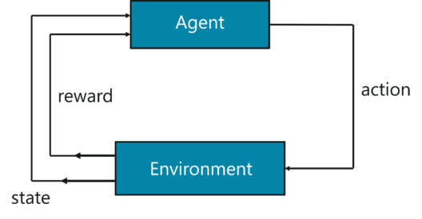

*Markov’s Decision Process – Artificial Intelligence Interview Questions – Edureka*

To briefly sum it up, the agent must take an action (A) to transition from the start state to the end state (S). While doing so, the agent receives rewards (R) for each action he takes. The series of actions taken by the agent, define the policy (π) and the rewards collected define the value (V). The main goal here is to maximize rewards by choosing the optimum policy.

To better understand the MDP, let’s solve the Shortest Path Problem using the MDP approach:

*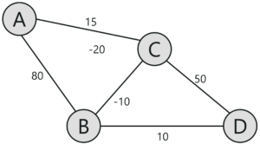Shortest Path Problem – Artificial Intelligence Interview Questions – Edureka*

Given the above representation, our goal here is to find the shortest path between ‘A’ and ‘D’. Each edge has a number linked with it, this denotes the cost to traverse that edge. Now, the task at hand is to traverse from point ‘A’ to ‘D’, with minimum possible cost.

In this problem,

* The set of states are denoted by nodes i.e. {A, B, C, D}
* The action is to traverse from one node to another {A -> B, C -> D}
* The reward is the cost represented by each edge
* The policy is the path taken to reach the destination

You start off at node A and take baby steps to your destination. Initially, only the next possible node is visible to you, thus you randomly start off and then learn as you traverse through the network. The main goal is to choose the path with the lowest cost.

Since this is a very simple problem, I will leave it for you to solve. Make sure you mention the answer in the comment section.

**Q3. Explain reward maximization in Reinforcement Learning.**

*The RL agent works based on the theory of reward maximization. This is exactly why the RL agent must be trained in such a way that, he takes the best action so that the reward is maximum.*

The collective rewards at a particular time with the respective action is written as:

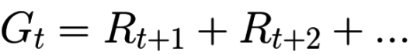

*Reward Maximization Equation – Artificial Intelligence Interview Questions – Edureka*

The above equation is an ideal representation of rewards. Generally, things don’t work out like this while summing up the cumulative rewards.

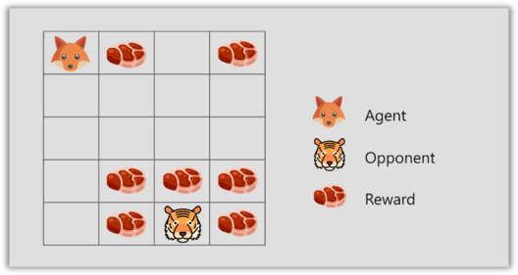

*Reward Maximization – Artificial Intelligence Interview Questions – Edureka*

Let me explain this with a small game. In the figure you can see a fox, some meat and a tiger.

* Our RL agent is the fox and his end goal is to eat the maximum amount of meat before being eaten by the tiger.
* Since this fox is a clever fellow, he eats the meat that is closer to him, rather than the meat which is close to the tiger, because the closer he is to the tiger, the higher are his chances of getting killed.
* As a result, the rewards near the tiger, even if they are bigger meat chunks, will be discounted. This is done because of the uncertainty factor, that the tiger might kill the fox.

The next thing to understand is, how discounting of rewards work?  
To do this, we define a discount rate called gamma. The value of gamma is between 0 and 1. The smaller the gamma, the larger the discount and vice versa.

So, our cumulative discounted rewards is:

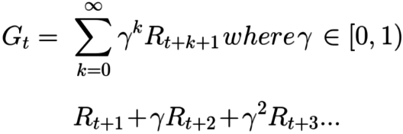

*Reward Maximization with Discount Equation – Artificial Intelligence Interview Questions – Edureka*

**Q4. What is exploitation and exploration trade-off?**

An important concept in reinforcement learning is the exploration and exploitation trade-off.

[[](https://www.edureka.co/machine-learning-engineer-training)](https://www.edureka.co/machine-learning-engineer-training" \t "_blank)

**[Machine Learning Engineer Masters Program](https://www.edureka.co/machine-learning-engineer-training" \t "_blank)**

[Explore Curriculum](https://www.edureka.co/machine-learning-engineer-training" \t "_blank)

*Exploration, like the name suggests, is about exploring and capturing more information about an environment. On the other hand, exploitation is about using the already known exploited information to heighten the rewards*.



*Exploitation & Exploration – Artificial Intelligence Interview Questions – Edureka*

* Consider the fox and tiger example, where the fox eats only the meat (small) chunks close to him but he doesn’t eat the bigger meat chunks at the top, even though the bigger meat chunks would get him more rewards.
* If the fox only focuses on the closest reward, he will never reach the big chunks of meat, this is called exploitation.
* But if the fox decides to explore a bit, it can find the bigger reward i.e. the big chunk of meat. This is exploration.

**Q5. What is the difference between parametric & non-parametric models?**

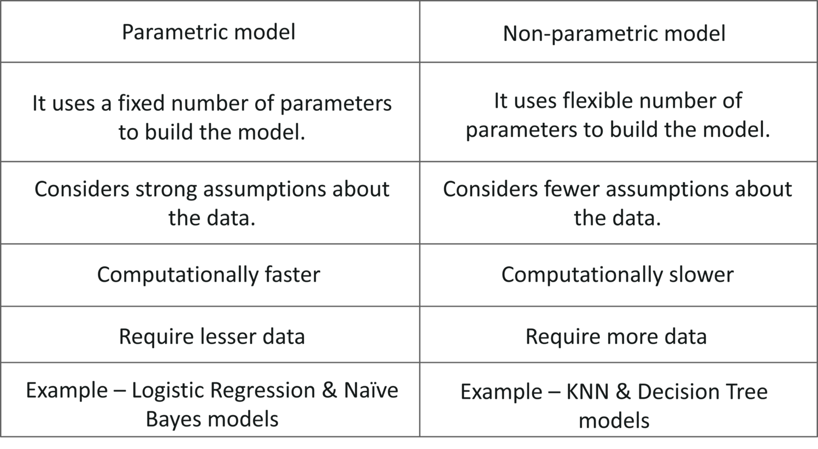

*Parametric vs Non Parametric model – Artificial Intelligence Interview Questions – Edureka*

**Q6. What is the difference between Hyperparameters and model parameters?**

**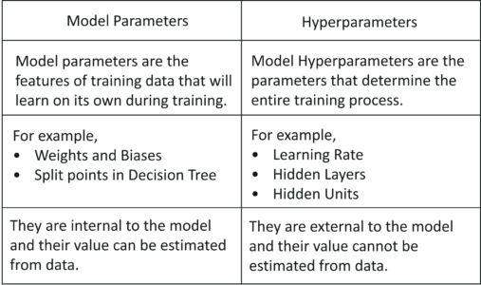**

*Model Parameters vs Hyperparameters – Artificial Intelligence Interview Questions – Edureka*

**Q7. What are hyperparameters in Deep Neural Networks?**

* Hyperparameters are variables that define the structure of the network. For example, variables such as the learning rate, define how the network is trained.
* They are used to define the number of hidden layers that must be present in a network.
* More hidden units can increase the accuracy of the network, whereas a lesser number of units may cause underfitting.

**Q8. Explain the different algorithms used for hyperparameter optimization.**

**Grid Search**  
Grid search trains the network for every combination by using the two set of hyperparameters, learning rate and the number of layers. Then evaluates the model by using Cross Validation techniques.

**Random Search**  
It randomly samples the search space and evaluates sets from a particular probability distribution. For example, instead of checking all 10,000 samples, randomly selected 100 parameters can be checked.

**Bayesian Optimization**  
This includes fine-tuning the hyperparameters by enabling automated model tuning. The model used for approximating the objective function is called surrogate model (Gaussian Process). Bayesian Optimization uses Gaussian Process (GP) function to get posterior functions to make predictions based on prior functions.

**Q9. How does data overfitting occur and how can it be fixed?**

 Overfitting occurs when a statistical model or machine learning algorithm captures the noise of the data. This causes an algorithm to show low bias but high variance in the outcome.

Overfitting can be prevented by using the following methodologies:

**Cross-validation:** The idea behind cross-validation is to split the training data in order to generate multiple mini train-test splits. These splits can then be used to tune your model.

**More training data:**Feeding more data to the machine learning model can help in better analysis and classification. However, this does not always work.

**Remove features:** Many times, the data set contains irrelevant features or predictor variables that are not needed for analysis. Such features only increase the complexity of the model, thus leading to possibilities of data overfitting. Therefore, such redundant variables must be removed.

**Early stopping:**A machine learning model is trained iteratively, this allows us to check how well each iteration of the model performs. But after a certain number of iterations, the model’s performance starts to saturate. Further training will result in overfitting, thus one must know where to stop the training. This can be achieved by a mechanism called early stopping.

**Regularization:**Regularization can be done in n number of ways, the method will depend on the type of learner you’re implementing. For example, pruning is performed on decision trees, the dropout technique is used on neural networks and parameter tuning can also be applied to solve overfitting issues.

**Use Ensemble models:** Ensemble learning is a technique that is used to create multiple Machine Learning models, which are then combined to produce more accurate results. This is one of the best ways to prevent overfitting. An example is Random Forest, it uses an ensemble of decision trees to make more accurate predictions and to avoid overfitting.

**Q10. Mention a technique that helps to avoid overfitting in a neural network.**

*Dropout is a type of regularization technique used to avoid overfitting in a neural network. It is a technique where randomly selected neurons are dropped during training.*

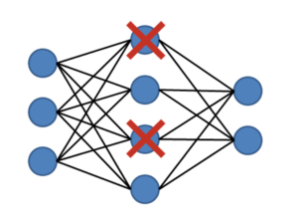

*Dropout – Artificial Intelligence Interview Questions – Edureka*

The Dropout value of a network must be chosen wisely. A value too low will result in a minimal effect and a value too high results in under-learning by the network.

**Q11. What is the purpose of Deep Learning frameworks such as Keras, TensorFlow, and PyTorch?**

* Keras is an open source neural network library written in Python. It is designed to enable fast experimentation with deep neural networks.
* [TensorFlow](https://www.edureka.co/blog/tensorflow-tutorial/) is an open-source software library for dataflow programming. It is used for machine learning applications like neural networks.
* [PyTorch](https://www.edureka.co/blog/pytorch-tutorial/) is an open source machine learning library for Python, based on Torch. It is used for applications such as natural language processing.

**Q12. Differentiate between NLP and Text mining.**

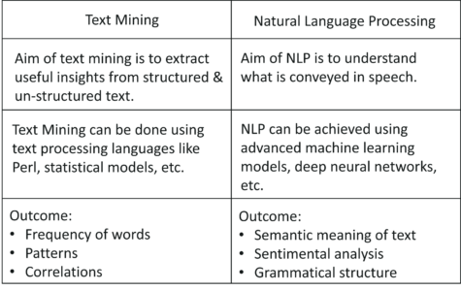

*Text Mining vs NLP – Artificial Intelligence Interview Questions – Edureka*

**Q13. What are the different components of NLP?**

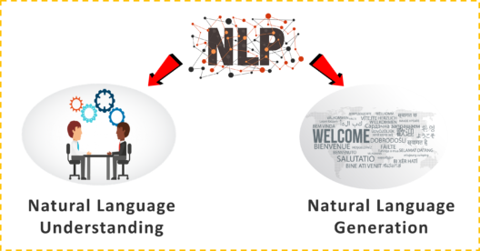

*Components Of NLP – Artificial Intelligence Interview Questions – Edureka*

Natural Language Understanding includes:

* Mapping input to useful representations
* Analyzing different aspects of the language

Natural Language Generation includes:

* Text Planning
* Sentence Planning
* Text Realization

**Q14. What is Stemming & Lemmatization in NLP?**

Stemming algorithms work by cutting off the end or the beginning of the word, taking into account a list of common prefixes and suffixes that can be found in an inflected word. This indiscriminate cutting can be successful on some occasions, but not always.

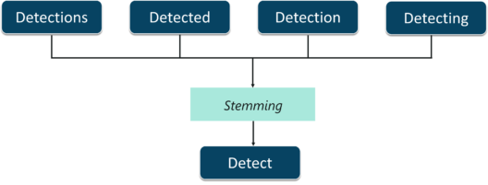

*Stemming – Artificial Intelligence Interview Questions – Edureka*

Lemmatization, on the other hand, takes into consideration the morphological analysis of the words. To do so, it is necessary to have detailed dictionaries which the algorithm can look through to link the form back to its lemma.

**Q15. Explain Fuzzy Logic architecture.**

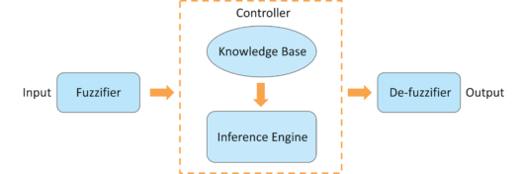

*Fuzzy Logic Architecture – Artificial Intelligence Interview Questions – Edureka*

* **Fuzzification Module** − The system inputs are fed into the Fuzzifier, which transforms the inputs into fuzzy sets.
* **Knowledge Base** − It stores analytic measures such as IF-THEN rules provided by experts.
* **Inference Engine** − It simulates the human reasoning process by making fuzzy inference on the inputs and IF-THEN rules.
* **Defuzzification Module** − It transforms the fuzzy set obtained by the inference engine into a crisp value.

**Q16. Explain the components of Expert Systems.**

**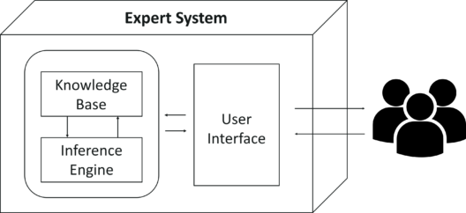**

*Expert Systems – Artificial Intelligence Interview Questions – Edureka*

* **Knowledge Base**  
  It contains domain-specific and high-quality knowledge.
* **Inference Engine**  
  It acquires and manipulates the knowledge from the knowledge base to arrive at a particular solution.
* **User Interface**  
  The user interface provides interaction between the user and the Expert System itself.

**Q17. How is Computer Vision and AI related?**

Computer Vision is a field of Artificial Intelligence that is used to obtain information from images or multi-dimensional data. Machine Learning algorithms such as K-means is used for Image Segmentation, Support Vector Machine is used for Image Classification and so on.

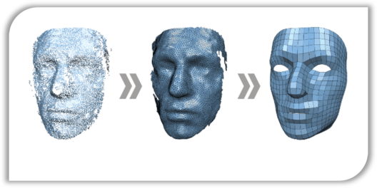

*Computer Vision And AI – Artificial Intelligence Interview Questions – Edureka*

Therefore Computer Vision makes use of AI technologies to solve complex problems such as Object Detection, Image Processing, etc.

**Q18. Which is better for image classification? Supervised or unsupervised classification? Justify.**

* In supervised classification, the images are manually fed and interpreted by the Machine Learning expert to create feature classes.
* In unsupervised classification, the Machine Learning software creates feature classes based on image pixel values.

Therefore, it is better to choose supervised classification for image classification in terms of accuracy.

**Q19. Finite difference filters in image processing are very susceptible to noise. To cope up with this, which method can you use so that there would be minimal distortions by noise?**

Image Smoothing is one of the best methods used for reducing noise by forcing pixels to be more like their neighbors, this reduces any distortions caused by contrasts.



*Image Smoothing – Artificial Intelligence Interview Questions – Edureka*

**Q20. How is Game theory and AI related?**

*“In the context of artificial intelligence(AI) and deep learning systems, game theory is essential to enable some of the key capabilities required in multi-agent environments in which different AI programs need to interact or compete in order to accomplish a goal.”*



*Game Theory And AI – Artificial Intelligence Interview Questions – Edureka*

**Q21. What is the Minimax Algorithm? Explain the terminologies involved in a Minimax problem.**

*Minimax is a recursive algorithm used to select an optimal move for a player assuming that the other player is also playing optimally.*

A game can be defined as a search problem with the following components:

* **Game Tree:** A tree structure containing all the possible moves.
* **Initial state:** The initial position of the board and showing whose move it is.
* **Successor function:** It defines the possible legal moves a player can make.
* **Terminal state:** It is the position of the board when the game ends.
* **Utility function:** It is a function which assigns a numeric value for the outcome of a game.

**Artificial Intelligence Scenario Based Interview Question**

**Q1. Show the working of the Minimax algorithm using Tic-Tac-Toe Game.**

There are two players involved in a game:

* **MAX:** This player tries to get the highest possible score
* **MIN:** MIN tries to get the lowest possible score

The following approach is taken for a Tic-Tac-Toe game using the Minimax algorithm:

**Step 1:** First, generate the entire game tree starting with the current position of the game all the way up to the terminal states.

**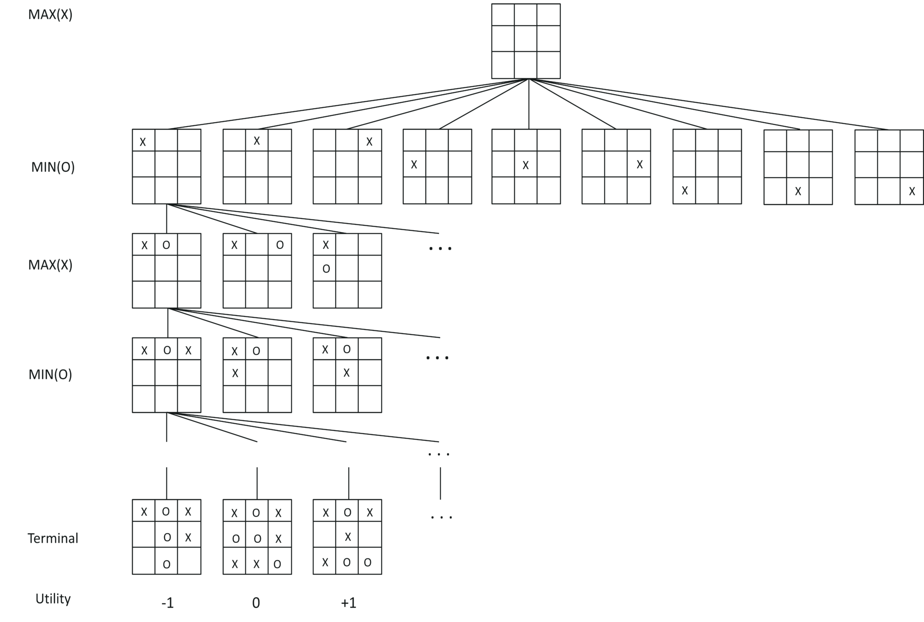**

*Tic-Tac-Toe – Artificial Intelligence Interview Questions – Edureka*

**Step 2:** Apply the utility function to get the utility values for all the terminal states.

**Step 3:** Determine the utilities of the higher nodes with the help of the utilities of the terminal nodes. For instance, in the diagram below, we have the utilities for the terminal states written in the squares.

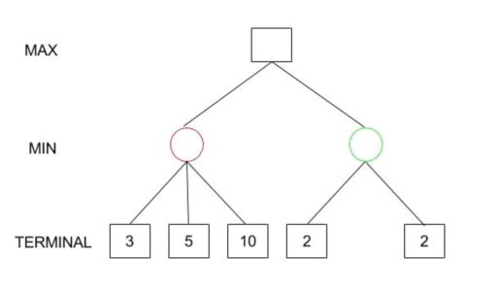

*Tic-Tac-Toe – Artificial Intelligence Interview Questions – Edureka*

Let us calculate the utility for the left node(red) of the layer above the terminal:

*MIN{3, 5, 10}, i.e. 3.*  
*Therefore, the utility for the red node is 3.*

*Similarly, for the green node in the same layer:*  
*MIN{2,2}, i.e. 2.*

**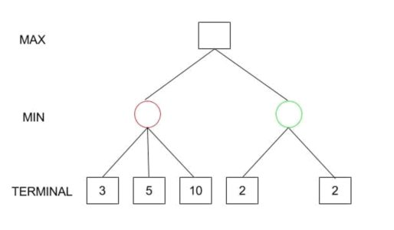**

*Tic-Tac-Toe – Artificial Intelligence Interview Questions – Edureka*

**Step 4:** Calculate the utility values.

**Step 5:** Eventually, all the backed-up values reach to the root of the tree. At that point, MAX has to choose the highest value:  
*i.e. MAX{3,2} which is 3.*

Therefore, the best opening move for MAX is the left node(or the red one).  
To summarize,

*Minimax Decision = MAX{MIN{3,5,10},MIN{2,2}}*  
*= MAX{3,2}*  
*= 3*

**Q2. Which method is used for optimizing a Minimax based game?**

**Alpha-beta Pruning**  
If we apply alpha-beta pruning to a standard minimax algorithm, it returns the same move as the standard one, but it removes all the nodes that are possibly not affecting the final decision.

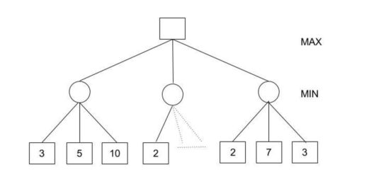

*Alpha-beta Pruning – Artificial Intelligence Interview Questions – Edureka*

In this case,  
*Minimax Decision = MAX{MIN{3,5,10}, MIN{2,a,b}, MIN{2,7,3}}*  
*= MAX{3,c,2}*  
*= 3*

**Artificial Intelligence Training**

**[AI & DEEP LEARNING WITH TENSORFLOW](https://www.edureka.co/ai-deep-learning-with-tensorflow" \o "AI & Deep Learning with TensorFlow" \t "_blank)**

**[AI & Deep Learning with TensorFlow](https://www.edureka.co/ai-deep-learning-with-tensorflow" \o "AI & Deep Learning with TensorFlow" \t "_blank)**

*[Reviews](https://www.edureka.co/ai-deep-learning-with-tensorflow" \o "AI & Deep Learning with TensorFlow" \t "_blank)*

**[5](https://www.edureka.co/ai-deep-learning-with-tensorflow" \o "AI & Deep Learning with TensorFlow" \t "_blank)**[(17603)](https://www.edureka.co/ai-deep-learning-with-tensorflow" \o "AI & Deep Learning with TensorFlow" \t "_blank)

**[NATURAL LANGUAGE PROCESSING WITH PYTHON CERTIFICATION COURSE](https://www.edureka.co/python-natural-language-processing-course" \o "Natural Language Processing with Python Certification Course" \t "_blank)**

**[Natural Language Processing with Python Certification Course](https://www.edureka.co/python-natural-language-processing-course" \o "Natural Language Processing with Python Certification Course" \t "_blank)**

*[Reviews](https://www.edureka.co/python-natural-language-processing-course" \o "Natural Language Processing with Python Certification Course" \t "_blank)*

**[5](https://www.edureka.co/python-natural-language-processing-course" \o "Natural Language Processing with Python Certification Course" \t "_blank)**[(2032)](https://www.edureka.co/python-natural-language-processing-course" \o "Natural Language Processing with Python Certification Course" \t "_blank)

**[MACHINE LEARNING WITH MAHOUT CERTIFICATION TRAINING](https://www.edureka.co/mahout-self-paced" \o "Machine Learning with Mahout Certification Training" \t "_blank)**

**[Machine Learning with Mahout Certification Training](https://www.edureka.co/mahout-self-paced" \o "Machine Learning with Mahout Certification Training" \t "_blank)**

*[Reviews](https://www.edureka.co/mahout-self-paced" \o "Machine Learning with Mahout Certification Training" \t "_blank)*

**[5](https://www.edureka.co/mahout-self-paced" \o "Machine Learning with Mahout Certification Training" \t "_blank)**[(8733)](https://www.edureka.co/mahout-self-paced" \o "Machine Learning with Mahout Certification Training" \t "_blank)

**[REINFORCEMENT LEARNING](https://www.edureka.co/reinforcement-learning-course" \o "Reinforcement Learning" \t "_blank)**

**[Reinforcement Learning](https://www.edureka.co/reinforcement-learning-course" \o "Reinforcement Learning" \t "_blank)**

*[Reviews](https://www.edureka.co/reinforcement-learning-course" \o "Reinforcement Learning" \t "_blank)*

**[5](https://www.edureka.co/reinforcement-learning-course" \o "Reinforcement Learning" \t "_blank)**[(1289)](https://www.edureka.co/reinforcement-learning-course" \o "Reinforcement Learning" \t "_blank)

**[GRAPHICAL MODELS CERTIFICATION TRAINING](https://www.edureka.co/graphical-modelling-course" \o "Graphical Models Certification Training" \t "_blank)**

**[Graphical Models Certification Training](https://www.edureka.co/graphical-modelling-course" \o "Graphical Models Certification Training" \t "_blank)**

*[Reviews](https://www.edureka.co/graphical-modelling-course" \o "Graphical Models Certification Training" \t "_blank)*

**[5](https://www.edureka.co/graphical-modelling-course" \o "Graphical Models Certification Training" \t "_blank)**[(1237)](https://www.edureka.co/graphical-modelling-course" \o "Graphical Models Certification Training" \t "_blank)

Next

*Hint: (MIN{2,a,b} would certainly be less than or equal to 2, i.e., c<=2 and hence MAX{3,c,2} has to be 3.)*

**Q3. Which algorithm does Facebook use for face verification and how does it work?**

*Facebook uses DeepFace for face verification. It works on the face verification algorithm, structured by Artificial Intelligence (AI) techniques using neural network models.*

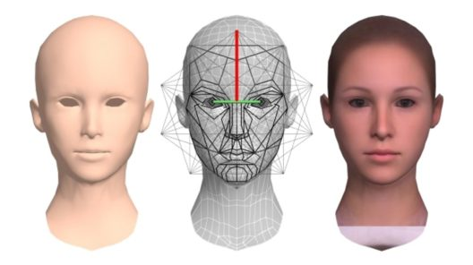

*Face Verification – Artificial Intelligence Interview Questions – Edureka*

Here’s how face verification is done:

**Input:** Scan a wild form of photos with large complex data. This involves blurry images, images with high intensity and contrast.

**Process:** In modern face recognition, the process completes in 4 raw steps:

* Detect facial features
* Align and compare the features
* Represent the key patterns by using 3D graphs
* Classify the images based on similarity

**Output:** Final result is a face representation, which is derived from a 9-layer deep neural net

**Training Data:** More than 4 million facial images of more than 4000 people

**Result:** Facebook can detect whether the two images represent the same person or not

**Q4. Explain the logic behind targeted marketing. How can Machine Learning help with this?**

*Target Marketing involves breaking a market into segments & concentrating it on a few key segments consisting of the customers whose needs and desires most closely match your product.*

It is the key to attracting new business, increasing your sales, and growing the company.

The beauty of target marketing is that by aiming your marketing efforts at specific groups of consumers it makes the promotion, pricing, and distribution of your products and/or services easier and more cost-effective.



*Targeted Marketing – Artificial Intelligence Interview Questions – Edureka*

Machine Learning in targeted marketing:

* ***Text Analytics Systems:***The applications for text analytics ranges from search applications, text classification, named entity recognition, to pattern search and replace applications.
* ***Clustering:***With applications including customer segmentation, fast search, and visualization.
* ***Classification:***Like decision trees and neural network classifiers, which can be used for text classification in marketing.
* ***Recommender Systems:*** And association rules which can be used to analyze your marketing data
* ***Market Basket Analysis:***Market basket analysis explains the combinations of products that frequently  
  co-occur in transactions.

**Q5. How can AI be used in detecting fraud?**

 Artificial Intelligence is used in Fraud detection problems by implementing Machine Learning algorithms for detecting anomalies and studying hidden patterns in data.

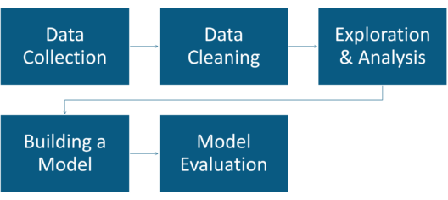

*Fraud Detection Using AI – Artificial Intelligence Interview Questions – Edureka*

The following approach is followed for detecting fraudulent activities:

**Data Extraction:** At this stage data is either collected through a survey or web scraping is performed. If you’re trying to detect credit card fraud, then information about the customer is collected. This includes transactional, shopping, personal details, etc.

**Data Cleaning:** At this stage, the redundant data must be removed. Any inconsistencies or missing values may lead to wrongful predictions, therefore such inconsistencies must be dealt with at this step.

**Data Exploration & Analysis:** This is the most important step in AI. Here you study the relationship between various predictor variables. For example, if a person has spent an unusual sum of money on a particular day, the chances of a fraudulent occurrence are very high. Such patterns must be detected and understood at this stage.

**Building a Machine Learning model:** There are many machine learning algorithms that can be used for detecting fraud. One such example is Logistic Regression, which is a classification algorithm. It can be used to classify events into 2 classes, namely, fraudulent and non-fraudulent.

**Model Evaluation:** Here, you basically test the efficiency of the machine learning model. If there is any room for improvement, then parameter tuning is performed. This improves the accuracy of the model.

**Q6. A bank manager is given a data set containing records of 1000s of applicants who have applied for a loan. How can AI help the manager understand which loans he can approve? Explain.**

This problem statement can be solved using the KNN algorithm, that will classify the applicant’s loan request into two classes:

1. Approved
2. Disapproved

*K Nearest Neighbour is a Supervised Learning algorithm that classifies a new data point into the target class, depending on the features of its neighboring data points.*



*Bank Loan Approval Using AI – Artificial Intelligence Interview Questions – Edureka*

The following steps can be carried out to predict whether a loan must be approved or not:

**Data Extraction:** At this stage data is either collected through a survey or web scraping is performed. Data about the customers must be collected. This includes their account balance, credit amount, age, occupation, loan records, etc. By using this data, we can predict whether or not to approve the loan of an applicant.

**Data Cleaning:** At this stage, the redundant variables must be removed. Some of these variables are not essential in predicting the loan of an applicant, for example, variables such as Telephone, Concurrent credits, etc. Such variables must be removed because they will only increase the complexity of the Machine Learning model.

**Data Exploration & Analysis:** This is the most important step in AI. Here you study the relationship between various predictor variables. For example, if a person has a history of unpaid loans, then the chances are that he might not get approval on his loan applicant. Such patterns must be detected and understood at this stage.

**Building a Machine Learning model:** There are n number of machine learning algorithms that can be used for predicting whether an applicant loan request is approved or not. One such example is the K-Nearest Neighbor, which is a classification and a regression algorithm. It will classify the applicant’s loan request into two classes, namely, Approved and Disapproved.

**Model Evaluation:** Here, you basically test the efficiency of the machine learning model. If there is any room for improvement, then parameter tuning is performed. This improves the accuracy of the model.

**Q7. You’ve won a 2-million-dollar worth lottery’ we all get such spam messages. How can AI be used to detect and filter out such spam messages?**

To understand spam detection, let’s take the example of Gmail. Gmail makes use of machine learning to filter out such spam messages from our inbox. These spam filters are used to classify emails into two classes, namely spam and non-spam emails.

Let’s understand how spam detection is done using machine learning:

**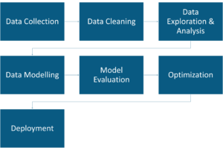**

*Spam Detection Using AI – Artificial Intelligence Interview Questions – Edureka*

* A machine learning process always begins with data collection. We all know the data Google has, is not obviously in paper files. They have data centers which maintain the customer’s data. Data such as email content, header, sender, etc are stored.
* This is followed by data cleaning. It is essential to get rid of unnecessary stop words and punctuations so that only the relevant data is used for creating a precise machine learning model. Therefore, in this stage stop words such as ‘the’, ‘and’, ‘a’ are removed. The text is formatted in such a way that it can be analyzed.
* After data cleaning comes data exploration and analysis. Many a time, certain words or phrases are frequently used in spam emails. Words like “lottery”, “earn”, “full-refund” indicate that the email is more likely to be a spam one. Such words and co-relations must be understood in this stage.
* After retrieving useful insights from data, a machine learning model is built. For classifying emails as either spam or non-spam you can use machine learning algorithms like [Logistic Regression](https://www.edureka.co/blog/logistic-regression-in-r/), Naïve Bayes, etc. The machine learning model is built using the training dataset. This data is used to train the model and make it learn by using past user email data.
* This stage is followed by model evaluation. In this phase, the model is tested using the testing data set, which is nothing but a new set of emails. After which the machine learning model is graded based on the accuracy with which it was able to classify the emails correctly.
* Once the evaluation is over, any further improvement in the model can be achieved by tuning a few variables/parameters. This stage is also known as parameter tuning. Here, you basically try to improve the efficiency of the machine learning model by tweaking a few parameters that you used to build the model.
* The last stage is deployment. Here the model is deployed to the end users, where it processes emails in real time and predicts whether the email is spam or non-spam.

**Q8. Let’s say that you started an online shopping business and to grow your business, you want to forecast the sales for the upcoming months. How would you do this? Explain.**

This can be done by studying the past data and building a model that shows how the sales have varied over a period of time. Sales Forecasting is one of the most common applications of AI. Linear Regression is one of the best Machine Learning algorithms used for forecasting sales.

When both sales and time have a linear relationship, it is best to use a simple linear regression model.

[*Linear Regression*](https://www.edureka.co/blog/linear-regression-in-r/)*is a method to predict dependent variable (Y) based on values of independent variables (X). It can be used for the cases where we want to predict some continuous quantity.*

* Dependent variable (Y):  
  *The response variable whose value needs to be predicted.*
* Independent variable (X):  
  *The predictor variable used to predict the response variable.*

In this example, the dependent variable ‘Y’ represents the sales and the independent variable ‘X’ represents the time period. Since the sales vary over a period of time, sales is the dependent variable.

**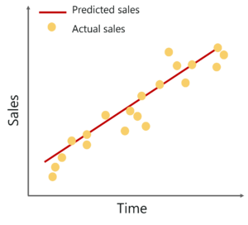**

*Forecasting Sales Using AI – Artificial Intelligence Interview Questions – Edureka*

The following equation is used to represent a linear regression model:

*Y=𝒃𝟎+𝒃𝟏 𝒙+ⅇ*

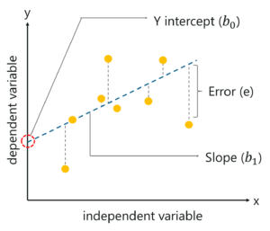

*Linear Regression – Artificial Intelligence Interview Questions – Edureka*

Here,

* Y = Dependent variable
* 𝒃𝟎 = Y-Intercept
* 𝒃𝟏 = Slope of the line
* x = Independent variable
* e = Error

Therefore, by using the Linear Regression model, wherein Y-axis represents the sales and X-axis denotes the time period, we can easily predict the sales for the upcoming months.

**Q9. ‘Customers who bought this also bought this…’ we often see this when we shop on Amazon. What is the logic behind recommendation engines?**

E-commerce websites like Amazon make use of Machine Learning to recommend products to their customers. The basic idea of this kind of recommendation comes from collaborative filtering. Collaborative filtering is the process of comparing users with similar shopping behaviors in order to recommend products to a new user with similar shopping behavior.

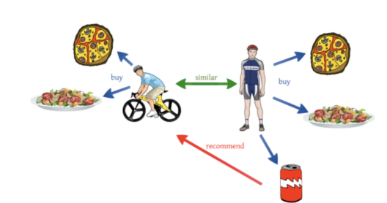

*Recommendation System Using AI – Artificial Intelligence Interview Questions – Edureka*

To better understand this, let’s look at an example. Let’s say a user A who is a sports enthusiast bought, pizza, pasta, and a coke. Now a couple of weeks later, another user B who rides a bicycle buys pizza and pasta. He does not buy the coke, but Amazon recommends a bottle of coke to user B since his shopping behaviors and his lifestyle is quite similar to user A. This is how collaborative filtering works.

**Q10. What is market basket analysis and how can Artificial Intelligence be used to perform this?**

*Market basket analysis explains the combinations of products that frequently co-occur in transactions.*

For example, if a person buys bread, there is a 40% chance that he might also buy butter. By understanding such correlations between items, companies can grow their businesses by giving relevant offers and discount codes on such items.

Market Basket Analysis is a well-known practice that is followed by almost every huge retailer in the market. The logic behind this is Machine Learning algorithms such as Association Rule Mining and Apriori algorithm:

* *Association rule mining is a technique that shows how items are associated with each other.*
* *Apriori algorithm uses frequent itemsets to generate association rules. It is based on the concept that a subset of a frequent itemset must also be a frequent itemset.*

**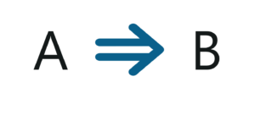**

*Association Rule Mining – Artificial Intelligence Interview Questions – Edureka*

For example, the above rule suggests that, if a person buys item A then he will also buy item B. In this manner the retailer can give a discount offer which states that on purchasing Item A and B, there will be a 30% off on item C. Such rules are generated using Machine Learning. These are then applied on items in order to increase sales and grow a business.

**Q11. Place an agent in any one of the rooms (0,1,2,3,4) and the goal is to reach outside the building (room 5). Can this be achieved through AI? If yes, explain how it can be done.**

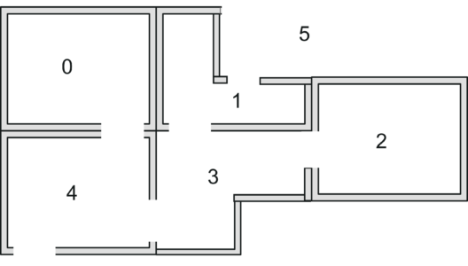

*Reinforcement Learning – Artificial Intelligence Interview Questions – Edureka*

In the above figure:

* 5 rooms in a building connected by doors
* Each room is numbered 0 through 4
* The outside of the building can be thought of as one big room (5)
* Doors 1 and 4 directly lead into the building from room 5 (outside)

This problem can be solved by using the Q-Learning algorithm, which is a reinforcement learning algorithm used to solve reward based problems.

Let’s represent the rooms on a graph, each room as a node, and each door as a link, like so:

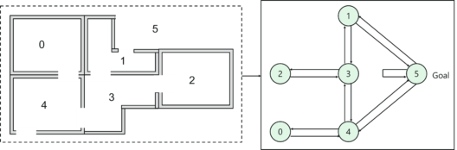

*Reinforcement Learning – Artificial Intelligence Interview Questions – Edureka*

Next step is to associate a reward value to each door:

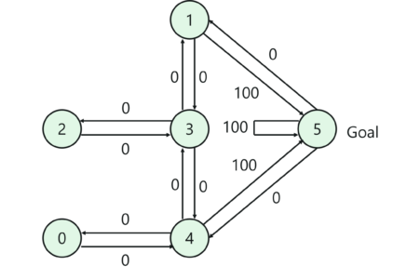

*Reinforcement Learning – Artificial Intelligence Interview Questions – Edureka*

* doors that lead directly to the goal have a reward of 100
* Doors not directly connected to the target room have zero reward
* Because doors are two-way, two arrows are assigned to each room
* Each arrow contains an instant reward value

Now let’s try to understand how Q-Learning can be used to solve this problem. The terminology in Q-Learning includes the terms state and action:

* The room (including room 5) represents a state
* Agent’s movement from one room to another represents an action

In the figure, a state is depicted as a node, while “action” is represented by the arrows. Suppose, the Agent traverses from room 2 to room5, then the following path is taken:

1. Initial state = state 2
2. State 2 -> state 3
3. State 3 -> state (2, 1, 4)
4. State 4 -> state 5

Next, we can put the state diagram and the instant reward values into a reward table or a matrix R, like so:

[[](https://www.edureka.co/machine-learning-engineer-training)](https://www.edureka.co/machine-learning-engineer-training" \t "_blank)

**[Machine Learning Engineer Masters Program](https://www.edureka.co/machine-learning-engineer-training" \t "_blank)**

[Weekday / Weekend BatchesSee Batch Details](https://www.edureka.co/machine-learning-engineer-training" \t "_blank)

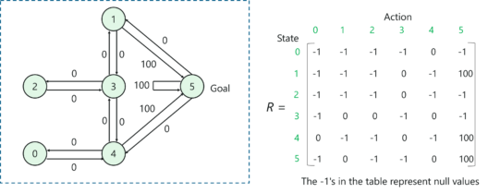

*Reinforcement Learning – Artificial Intelligence Interview Questions – Edureka*

The next step is to add another matrix Q, representing the memory of what the agent has learned through experience.

* The rows of matrix Q represent the current state of the agent
* columns represent the possible actions leading to the next state

The formula to calculate the Q matrix:

***Q(state, action) = R(state, action) + Gamma \* Max [Q(next state, all actions)]***

Here, Q(state, action) and R(state, action) represent the state and action in the Reward matrix R and the Memory matrix Q.

Note: The Gamma parameter has a range of 0 to 1 (0 <= Gamma > 1).

* If Gamma is closer to zero, the agent will tend to consider only immediate rewards.
* If Gamma is closer to one, the agent will consider future rewards with greater weight

Finally, by following the below steps, the agent will reach room 5 by taking the most optimal path:

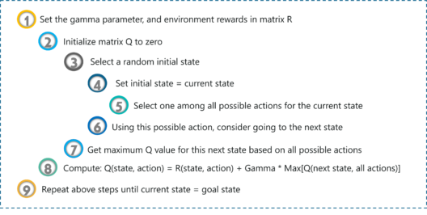

*Reinforcement Learning – Artificial Intelligence Interview Questions – Edureka*

**Q12. The crop yield in India is degrading because farmers are unable to detect diseases in crops during the early stages. Can AI be used for disease detection in crops? If yes, explain.**

*AI can be used to implement image processing and classification techniques for extraction and classification of leaf diseases.*

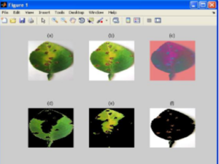

*Image Processing Using AI – Artificial Intelligence Interview Questions – Edureka*

This sounds complex, let me break it down into steps:

**Image Acquisition**: The sample images are collected and stored as an input database.

**Image Pre-processing:**Image pre-processing includes the following:

* Improve image data that suppresses unwanted distortion
* Enhance image features
* Image clipping, enhancement, color space conversion
* Perform Histogram equalization to adjust the contrast of an image

**Image Segmentation:** It is the process of partitioning a digital image into multiple segments so that image analysis becomes easier.  Segmentation is based on image features such as color, texture. A popular Machine Learning method used for segmentation is the K-means clustering algorithm.

**Feature Extraction:** This is done to extract information that can be used to find the significance of a given sample. The Haar Wavelet transform can be used for texture analysis and the computations can be done by using Gray-Level Co-Occurrence Matrix.

**Classification:** Finally, Linear [Support Vector Machine](https://www.edureka.co/blog/support-vector-machine-in-r/) is used for classification of leaf disease. SVM is a binary classifier which uses a hyperplane called the decision boundary between two classes. This results in the formation of two classes:

1. Diseased leaves
2. Healthy leaves

Therefore, AI can be used in Computer Vision to classify and detect disease by studying and processing images. This is one of the most profound applications of AI.

So these are the most frequently asked questions in an Artificial Intelligence Interview. However, if you wish to brush up more on your knowledge, you can go through these blogs:

* [Machine Learning Tutorial for Beginners](https://www.edureka.co/blog/machine-learning-tutorial/)
* [Deep Learning Tutorial: Artificial Intelligence Using Deep Learning](https://www.edureka.co/blog/deep-learning-tutorial)
* [Machine Learning Algorithms](https://www.edureka.co/blog/machine-learning-algorithms/)
* [A Guide To Machine Learning Interview Questions And Answers](https://www.edureka.co/blog/machine-learning-interview-questions/)
* [How to Become an Artificial Intelligence Engineer?](https://www.edureka.co/blog/become-artificial-intelligence-engineer/)

*With this, we come to an end of this blog. I hope these Artificial Intelligence Interview Questions will help you ace your AI Interview.*

*If you’re looking to learn more about AI, Edureka provides a specially curated*[***Machine Learning Engineer Master Program***](https://www.edureka.co/masters-program/machine-learning-engineer-training)*that will make you proficient in techniques like Supervised Learning, Unsupervised Learning, and Natural Language Processing. It includes training on the latest advancements and technical approaches in Artificial Intelligence & Machine Learning such as Deep Learning, Graphical Models and Reinforcement Learning.*